Online Teaching Brainstorming Worksheet

Please fill out this brainstorming worksheet to the best of your ability, keeping in mind the keyword – brainstorming! This is a place to help you formulate ideas and get them down on paper so that you can move forward with your instructional module. Do your best and share this worksheet with your critical friend for his/her perspectives when you are finished.

Name:

Course Name/Topic:

Entry 1: To the best of your ability, describe the course that you wish to develop to teach online. Some characteristics you may want to address include number of students, prerequisites for course, course goals, how it might typically be taught (e.g., lecture-based, seminar-style, lab-based), assignments that should be included, and assessment strategies.

Merrill’s First Principles

Consider Merrill’s First Principles of Design model as a guideline or roadmap toward formulating your course. Merrill’s First Principles is a modern instructional design model based on cognitive and constructivist theory. See http://mdavidmerrill.com/Papers/firstprinciplesbymerrill.pdf to read the original 2002 article describing this model in full.

We will go through each phase of the model to brainstorm how we will approach the overall design and content for this course, starting with the central task or problem.

Merrill, M.D. (2002). First principles of instruction. Educational Technology, 50(3), 43-59. doi: 10.1007/BF02505024

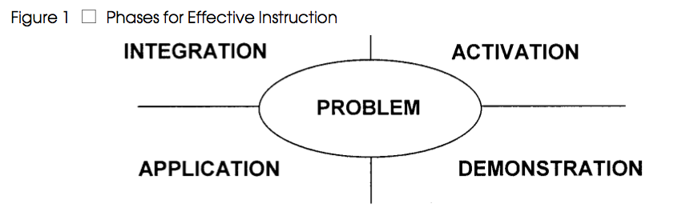

Principle 1—Problem-centered: Learning is promoted when learners are engaged in solving real-world problems.

Entry 2: Merrill proposes a task-first approach. Think about your overall goals for the course and identify at least one specific learning objective that addresses the task or problem students will learn to solve after completing your instructional module/course. Check your objective using the Audience-Behavior-Condition-Degree (ABCD) criteria.

Principle 2—Activation: Learning is promoted when relevant previous experience is activated.

Entry 3: For the learning objective(s) you specified above, think about how you might activate prior experience and lead students toward understanding of new experience and learning. In other words, how will you initially present the topic for learners in order for them to understand what they need to do and how they’ll do it? Ideas might include putting together PowerPoints or videos to introduce the topic, asking learners to participate in a discussion about a opening topic or question, or providing learners with an article to read and respond to. Identify at least one activity/method that you would use to activate learning.

Principle 3—Demonstration (Show me): Learning is promoted when the instruction demonstrates what is to be learned rather than merely telling information about what is to be learned.

Entry 4: Merrill (2002) indicated that learning is promoted best when demonstrations are provided that help learners understand the goal they’re working toward. Please describe at least one or two demonstration strategies you could use to help learners understand how to achieve their objectives. This might include providing examples of completed projects, providing relevant videos or other media to guide their thinking, or leading students through a case study of some kind.

Principle 4—Application (Let me): Learning is promoted when learners are required to use their new knowledge or skill to solve problems.

Entry 5: At this phase, you must decide how learners will be showing you what they learned and how they will be assessed as to whether they are moving toward meeting the objective or not. This is often considered an intermediate step toward full acquisition of the learning objectives, such as a practice or an intermediate assignment before a final exam or project presentation. How will you ask students to being applying what they are learning in the online environment? Identify at least two assessment activities/methods that you could use to assess student learning progress related to your specific objective(s) identified in Entry 2. Include not just the activity but also how you assess that activity (rubric for a discussion or project, quiz, observation via video, etc.).

Principle 5—Integration: Learning is promoted when learners are encouraged to integrate (transfer) the new knowledge or skill into their everyday life.

Entry 6: At the Integration phase, learners are ready to transfer their new knowledge into their work or into other contexts. This is when they are truly demonstrating that they have achieved the objectives set before them, and is usually also considered a time when they are able to thoughtfully reflect on as well as demonstrate their acquisition of new knowledge or skills. At this stage, they may create projects, respond with reflective comments in a discussion that show synthesis of skills, or complete a comprehensive exam of some kind. Describe how your learners will show their integration of learning with at least one strategy/activity and how you will assess their attainment (rubric, exam, etc.).

Online Environment Considerations

Entry 7: As you know, the online environment is different than face-to-face, and motivation and engagement are highly important. When learners are not engaged, they may not participate or learn as much, and online, you cannot see them to view body language and other cues. How will you encourage student participation and motivation in your instructional module? Identify several actions that you as the instructor should avoid and explain their potential impact on the development of motivation, a learning community, and ultimately student learning. Also, identify several actions/behaviors that you want to be sure your students avoid, and explain how you will communicate this to your students.

